CHAPTER-1 INTRODUCTION AND HISTORY

1.1 INTRODUCTION
In the new era of digital world multimedia plays an important role, for the need of multimedia the current display technologies are improving rapidly. The digital world needs big screen to express this beautiful world. The current CRT does not satisfy this because of its weight and cost matters.

After the arrival of liquid displays and plasma displays the screen size began to increase , and we know comfortable in sitting in front of a home theatre system with 60 inch wall mounted Dolby and digital sound. But we need bigger screens and also colour variations.

A new technology called technology that combines mechanical motion and electronic circuits. This will help for the implementation of such bigger screens. MEMS consist of two technologies they are Digital Micro Mirror Devices(DMD) and Grating Light Valves. The digital Micro mirror device is a chip that has anywhere from 800 to more million tiny mirrors on it, depending on the size of the array.

When a voltage is applied to either of the address electrodes, the mirrors can tilt +10 degree or -10 degree, representing on or off in a digital signal. In the GLV technology we can create an image on the screen with size of that of an average conference hall and variety of colour gradients with a high contrast ratio than the DMD technology, briefly we can display large images on a screen or even with the help of GLV module ,lasers and projection systems fir the need of the future display world.

1.2 HISTORY

The light valve was originally developed at Stanford University, in California, by electrical engineering professor David M. Bloom, along with Raj Apte, Francisco Sandejas, and Olav Solgaard. In 1994, the start-up company Silicon Light Machines was founded by Bloom to develop and commercialize the technology. The company is now wholly owned by Dainippon Screen Manufacturing Co., Ltd.

In July 2000, Sony anounced the signing of a technology licensing agreement with SLM for the implementation of GLV technology in laser projectors for large venues, but by 2004 Sony announced the SRX-R110 front projector using its own LCOS-based technology SXRD SLM then partnered with Evans & Sutherland (E&S). Using GLV technology, E&S developed the E&S Laser Projector, designed for use in domes and planetariums. The E&S Laser Projector was incorporated into the Digistar 3 dome projection system.

CHAPTER-2
2.1 GRATING LIGHT VALVE DISPLAY TECHNOLOGY:

Another MEMS device is the grating light valve (GLV). GLV technology, licensed to Sony, The light valve was originally developed at Stanford University, in California, by electrical engineering professor David M. Bloom, along with Raj Apte. Francisco Sandejas, and Olav Solgaard. and is now patented and produced by Silicon Light Machines in Sunnyvale, California.

The GLV chip consists of tiny reflective ribbons mounted over a silicon chip. The ribbons are suspended over the chip with a small air gap in between. When a voltage is applied to the chip below a ribbon, the ribbon moves toward the chip by a fraction of the wavelength of the illuminating light.

The deformed ribbons form a diffraction grating, and the various orders of light can be combined to form the pixel of an image. The shape of the ribbons, and therefore the image information, can be changed in as little as 20 billionths of a second.

To make a projector, the GLV pixels are arranged in a vertical line that is 1,080 pixels long. Light from three lasers, one red, one green and one blue, shines on the GLV and is rapidly scanned across the display screen at 60 frames per second to form the inuge.

A major advantage of GLV technology is that GLV chips can make high-resolution images at a relatively low cost. For example, because a 1,920x1.080 pixel image can be achieved by scanning a 1,080-pixel linear array, a GLV chip can be manufactured to achieve this resolution with only DMD. Also because the ribbons are aligned vertically, there are no horizontal gaps in the SO there is a very on the chip image When compared with DMD technology GLV offers the following advantages.

- Significantly faster operating speeds.

- High optical efficiency.

- Continuously variable attenuation.

- No contact surfaces-high reliability and stability.

2.2 FUNDAMENTAL CONCEPTS

A Grating Light Valve (GLV) device consists of parallel rows of reflective ribbons. Alternate rows of ribbons can be pulled down approximately one-quarter wavelength to create diffraction effects on incident light (see figure 1). When all the ribbons are in the same plane, incident light is reflected from their surfaces. By blocking light that returns along the same path as the incident light, this state of the ribbons produces a dark spot in a viewing system. When the (alternate) movable ribbons are pulled down, however, diffraction produces light at an angle that is different from that of the incident light. Unblocked, this light produces a bright spot in a viewing system.direct-to-plate printers, HDTV monitors, electronic cinema projectors and commercial flight simulator displays.

Silicon Light Machines is leveraging its successes to develop a portfolio of products based on current GLV structures and future derivatives, to serve the needs of its customers in the rapidly emerging optical communications network markets.

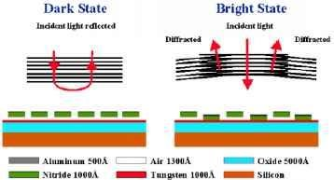

Fig1: working diagram of single

2.3 BUILDING THE GLV DEVICE

The following describes the materials, dimensions and packaging of a GLV device capable of implementing a high-resolution display. The entire GLV device is designed to be built using mainstream IC fabrication technology (e.g. photolithographic, masking, deposition, etching, metallization, etc.) to create the micro electromechanical systems (MEMS) that make up the GLV device. The GLVribbons are built using silicon nitride,then coated layer of aluminum (see figure ). By making the aluminum layer very thin, one avoids some of the surface roughness that otherwise scatters the light reducing the contrast ratio.

Fig2: Combination of GLV

In one implementation which Silicon Light Machines has built, the ribbon lengths are 20mm, and the ribbon pitch is 5mm. The pull-down distance is approximately 1300 Angstroms, or approximately one- quarter wavelength of green light. With these dimensions, a set of four ribbons(two fixed and two movable) produces a 20 (am square pixel figure3). The “up” position of the ribbons is maintained by the tensile stress of the silicon nitride material.

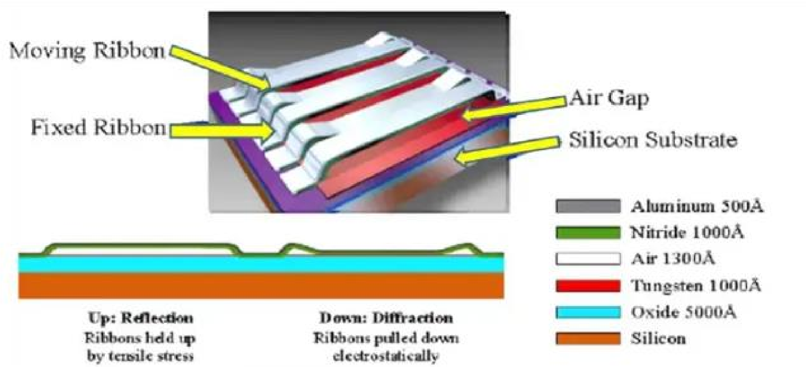
With no other forces applied, the ribbons will naturally “snap back” into an upward position. By integrating electrodes below the ribbons, and applying different voltages to the ribbons and the bottom electrodes, an electrostatic attraction force will pull the movable ribbons downward. The deflection distance is determined during manufacture. The basic GLV pixel is defined using a simple, 2-mask IC process. Silicon Light Machines has built devices using only 7 masks.

In general, the more masks needed to manufacture an IC, the higher the initial cost. And, each additional masking step has a negative impact on yield (i.e. the percentage of good versus faulty components). Thus, the simple GLV design should provide lower initial costs and higher yields compared with light-valve technologies that require more complex manufacturing.

When a voltage is applied to either of the address electrodes, the mirrors can tilt+10degree or -10 degree, representing on or off in a digital signal. Close-up photo of the parrot’s eye projected through a three-panel poly-silicon VGA resolution LCD projector (left image) and a one-chip VGA resolution DMD projector (right image). Both the LCD and DMD photos were taken under the same conditions.

When the GLV device is finished and tested, a clear glass lid is fixed above the ribbons area sealing in a dry nitrogen environment for pressure equalization and to prevent oxidation. As shown in Figure 3, additional electronic driver and control logic is built into a complete, light valve, multi-chip module.

CHAPTER-3

3.1CONTROLLING THE GLV DEVICE

To control a GLV-based device, one simply directs the up and down ribbon movement of this two -state technology. As mentioned previously, the ribbons will naturally assume the up state. To pull them down, one must apply a voltage difference (e.g. the switch-down voltage, V2) between the movable ribbons and bottom electrodes. Interestingly, the ribbons maintain their downstate even as the voltage differential is reduced. Thus, one can pull the ribbon down with a switch-down voltage (V2), and maintain that state with bias voltage, Vb, such that Vl<Vb<V2 volts (see Figure 4), where VI is the switch-up voltage at which the ribbon returns to its upstate. We have built such thatV2/V1is approximately2.
Thisribbonhysteresis permits oneto maintain presentpixel states with a bias volta ge, without drawing current. In other words, a static pixelconfiguration canbe maintained with practically zero power consumption. Other displaytechnologies require significantly more complex control circuits to maintain pixel state.

The up and down ribbon switching occurs very quickly. The GLV device described here switches in 20 nanoseconds. That is roughly a million times faster than conventional LCD display devices, and about 1000 times faster than another light-valve technology.
The reasons for the high speed are the small size and mass, and small excursion, of the GLV ribbon. This high-speed switching offers benefits.

At these speeds, it is easier to streamline drive electronics and to simplify the me mory requirements. There is no need to provide buffers or delay functions to complement the mismatch in speeds between electronic devices and this MEMS device. Another speed advantage is the ability to modulate, over a wide range, the time ratio of up-to-down states
(or dark and bright states) which produces the effect of shades of gray or color variations.

GLV switching speeds make it easy to implement an 8-bit or greater gray scale, and are fast enough to support colors and grays over a 1000 -to-1 dynamic range. This is much broader gray and color accuracy than is produced using LCD technology, for example. The combination of speed and mechanical memory (e.g. ribbon hysteresis) make controlling the GLV device very simple. An elegantly simple row and column addressing scheme can be used, and passive matrix (rather than the more complex active matrix) pixel control is all that is required.

This eliminates the need for any transistors in the GLV array itself, greatly simplifying the manufacturing process. The GLV device thus lends itself to an easy interface toother display system electronics. Contrast ratios, fill ratios and optical efficiencies are import ant metrics for distinguishing among various display technologies. High contrast ratios provide crisper images. AGLV system we built using relatively inexpensive optics exhibits a contrast ratio of better than200-to-l. Fill ratios — the ratio of optically active area to total pixel area is already better than typical LCDs. In a prototype GLV array we built using mature 1.25 microndesign rules, we achieve fill ratios of 67.5 percent compared with 60 percent for LCDs. Using more modern, smaller, design rules, fill ratios of 80 percent are expected.

Finally, optical efficiency for reflective devices is naturally higher than that for trans missive devices. In a typical GLV prototype, where the optical system collects +/-1 order of diffraction, about 81 percent of the incident light can be collected in the bright state. This makes for brighter images compared with other technologies when operated at comparable power consumption levels.

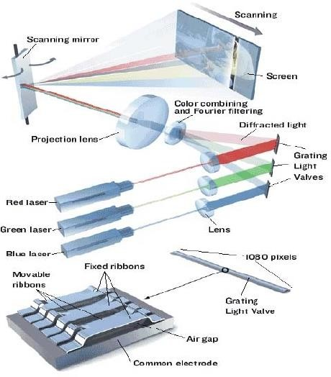

Fig3: GLV Projector

In this newly developed display technology, the [Grating Light Valve] device is the kernel that consists of one-dimensional diffraction gratings on a silicon base, manufactured using MEMS technology. The diffraction gratings can fractionally alter their shape by the use of electronic signals, i.e. the image signals can be used to control the grating ribbon's displacement to result in controlled diffracted light intensity, providing precise and accurate pixel-by-pixel brightness control. This key feature of [Grating Light Valve] device enables realization of smooth gradation control and a contrast ratio of over 3000:1, resulting in rich and detailed images. The [Grating Light Valve] device that Sony demonstrated today uses 6 ribbons as the diffraction gratings for each pixel and consists of total vertical number of HD-equivalent 1080 pixels (total of 6480 ribbons in a line).

The RGB laser light sources are illuminated as a line onto the corresponding [Grating Light Valve] device, forming a one-dimensional image of 1080 pixels. This one- dimensional image is then scanned horizontally using a scanning mirror to create a two- dimensional image. The present device allows horizontal scanning of 1920 pixels, providing capability for 1920 (horizontal) x 1080 (vertical), the same as full HD progressive image reproduction (Figure-5)& Specification are given in table.1. Specification of GLVP:

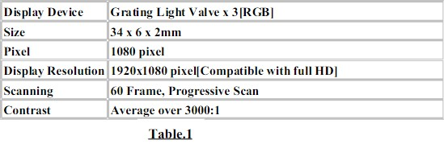

3.2 COMPARISION WITH OHER TECHNOLOGYS

To succeed as an alternative to existing display technologies; GLV technology must demonstrate some compelling benefits, and it does. Compared to its closest alternative-micro- mirror light valve technology the GLV device is much simpler to fabricate, requiring only 7 mask steps. GLV devices use smaller, lighter, mechanical structures that move through smaller excursions than alternative light-valve technologies.
Hence, it is faster, requires less external memory and no transistors in the MEMS array.

Several orders of magnitude faster than conventional LCDs and other light-valve technologies, GLV technology matches much more closely the speeds of its electronic interface components. As a result, the interface is simpler. GLV speeds also provide for higher gray scale and color variation accuracy. For example, a GLV device can be used to build a 10-bit -per-pixel, high-resolution display, compared with 8-bit-per-pixel, LCD displays.

Because GLV devices are built using mainstream IC fabrication technology, ribbon dimensions are easily scaled allowing the production of smaller, lower-cost, devices with higher resolution and fill ratios.

The GLV technology's MEMS architecture is exhibiting very encouraging reliability. Early experiments have shown no ribbon fatigue after 210 billion ribbon switching cycles. This is equivalent to a television display system running non-stop, without failure, for 15 years(Table 2).

With their higher optical efficiencies, GLV systems can deliver higher levels of brightness per watt of power consumed. Their small size makes it practical to build over a million pixels in a 1.3 inch diagonal. Coupled with their mass predictability, this makes the GLV a candidate for building high-resolution, low-cost displays. And their inherent zero-power pixel- state retention make them ideal for use in small, battery-powered devices.

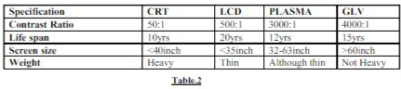

CHAPTER-4

4.1 GLV ARCHITECTURE

The GLV chip consists of tiny reflective ribbons mounted over a silicon chip. The ribbons are suspended parallel over the chip with a small air gap in between it and the substrate. This constitutes the 1080 pixels arranged linearly. The linear GLV array's 1,088 pixels are at a pitch of 25.5 um, thus giving a total active area of 25um by 27.7mm. The linear GLV array is surrounded by four custom driver chips (each with 272 output stages) and assembled into a multi- chip module. The primary function of the driver chips is to provide the digital- to-analog conversion needed for analog grayscale control. A linear GLV array can be used to modulate a single column of image data, while a mechanical scan mirror is used to sweep that column across the field of view.

A GLV pixel is an addressable diffraction grating created from moving parts on the surface of a silicon chip. A typical GLV pixel about 25 microns square in area and include six (even numbered) ribbons, each about 3 µm wide. 100 μm long, but only about
125 nm thick. These ribbons are suspended above a thin air gap (typically about 650 mm).

4.2 GLV IN PROJECTION TV:

In the Scanned GLV Architecture, a linear array of GLV pixels is used to project a single column of image data. This column is optically scanned at a high rate across a projection screen. As the scan moves horizontally. GLV pixels change states to represent successive columns of video data, forming one complete image per scan. The high inherent switching speed of GLV devices makes a scanned linear architecture, and its many benefits, possible. For example, to create a 1,920 x 1.080-HDTV image with a 100 Hz refresh rate, each column of video data is displayed in stasis for about 4.2 us (assuming a
20% flyback time); this requires a pixel switching time significantly less than 4.2 μs.

4.3 HIGH SPEED OPERATION FACTS:
The on/off switching speed (or the time required to switch between any other two arbitrary intermediate values) of the GLV device can be several orders of magnitude faster than competing technologies. Specific GLV devices capable of switching speeds as fast as 20 nanoseconds have been fabricated.

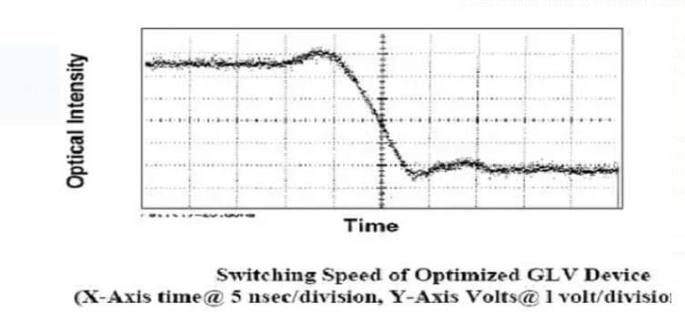

The fundamental switching time of the GLV element is related to the resonant mechanical frequency of the ribbon design, determined by such factors as ribbon length, ribbon width, ribbon tension, ribbon mass, composition of the surrounding atmosphere, etc. Because the GLV ribbon is a mechanical element, it can be subject to resonance effects that manifest themselves as a “ringing” characteristic following a step excitation. These dynamic effects can be mitigated through the proper design of electronic drive circuitry and by "tuning" the GLV device and its ambient atmosphere so that it is critically damped at its natural frequency. Extensive characterization and testing of such parameters allow Silicon Light Machines engineers to optimize the switching characteristics for a particular application. Given all of these trade-offs and design latitudes, a wide design space can be covered with the GLV technology. Depending, then, on the specific design trade-offs involved, for most optical communications applications, GLV devices can switch with sub-microsecond speeds.

4.4 Optical Efficiency

The optical efficiency of the GLV device depends on three main factors: 1) the diffraction efficiency, 2) the aperture ratio (the ratio of ribbon width to ribbon gap) and 3) the reflectivity of the top layer material chosen. In an ideal square-well diffraction grating, 81% of the diffracted light energy is directed into the +/- 1st orders. The gaps between GLV ribbons (defined by the minimum feature characteristics of the lithographic tools used to pattern the ribbons) do degrade optical efficiency, but not in the linear manner which intuition might suggest. Practical designs have been realized with an effective fill factor efficiency of about 95%. Reflectivity of the top layer depends on the choice of material selected. While other materials can be selected (such as gold), aluminum alloys typically used in semiconductor processes allow cost-effective manufacture and are greater than 90% reflective over most of the wavelengths used for optical communications and imaging applications. Device efficiency, then, is the product of diffraction efficiency (81%); fill factor efficiency (typically >95%), and aluminum reflectivity (typically >91%). Overall, the device efficiency is about 70%, corresponding to an insertion loss of about 1.5dB.

Efficiency, but not in the linear manner which intuition might suggest. Practical designs have been realized with an effective fill factor efficiency of about 95%. Reflectivity of the top layer depends on the choice of material selected. While other materials can be selected (such as gold), aluminum alloys typically used in semiconductor processes allow cost-effective manufacture and are greater than 90% reflective over most of the wavelengths used for optical communications and imaging applications. Device efficiency, then, is the product of diffraction efficiency (81%); fill factor efficiency (typically >95%), and aluminum reflectivity (typically >91%). Overall, the device efficiency is about 70%, corresponding to an insertion loss of about 1.5dB.

4.5 High Attenuation Accuracy
The GLV device performs smoothly and monotonically for well over three decades of intensity (see Figure 5).
The response of the GLV device to a given input voltage has been painstakingly modeled, and is well understood through extensive empirical data as well. Using 8-bit drivers, the GLV ribbons can be positioned with attenuation accuracy greater than 0.07dB. Use of higher resolution drivers (such as 10-bit) can allow for even greater attenuation accuracy in cases where this is required.

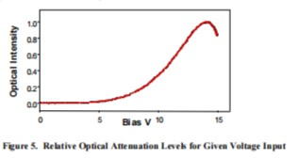

4.6 High Optical Precision

When a voltage is applied to alternate ribbons, the GLV device is set to a diffraction state. The source light is then diffracted at set angles, as illustrated in Figure 1. These diffraction angles are fixed with photolithographic accuracy when the GLV device is manufactured. Therefore, very precise light placement is achieved without the need for complex control electronics. This feature of the When a voltage is applied to alternate ribbons, the GLV device is set to a diffraction state. The source light is then diffracted at set angles, as illustrated in Figure 1. These diffraction angles are fixed with photolithographic accuracy when the GLV device is manufactured. Therefore, very precise light placement is achieved without the need for complex control electronics. This feature of the GLV device allows for significantly smaller and less expensive packaging and lower power requirements for optical components and subsystems.

4.7 High Reliability and Stability :

Another requirement for the optical communications market is high component reliability. The simple mechanical and electrical design of the GLV technology is intrinsically reliable. The ribbons (the only moving mechanical elements) are made of silicon nitride, a hard, amorphous, ceramic material grown by a stable thermal deposition process (LPCVD). The reflective (aluminum) top layer has minimal influence on ribbon mechanics. When fully actuated, the ribbons operate at less than 10% of Si3N4’s tensile breaking stress. Moreover, the ribbons operate in a non-contact mode with relatively small ribbon deflections. For purpose of illustration, if a GLV element were scaled up such that the ribbon length was 10 meters, the depth of deflection for a fully switched ribbon would be only 6.5 milli meters. GLV ribbons never experience contact, so there are none of the wear issues sometimes associated with other MEMS processes and devices.

Hermetically sealing the active ribbons under an optical glass lid which protects the delicate ribbon structures while still at the wafer level, thus eliminating contamination during subsequent processing and packaging. Because of the “mission critical” nature of optical communications systems, Silicon Light Machines has conducted a comprehensive, statistically based testing program to analyze the impacts of various types of component stress (e.g., thermal, mechanical, advanced cycles, high optical power) that most affect long-term GLV reliability, and to demonstrate reliable long-term GLV performance. The long-term stability of ribbon tension is crucial to the proper operation of GLV devices. For reliability testing, it is thus important to monitor even small changes in ribbon tension. The natural resonant response for an individual ribbon a characteristic damped oscillation when excited by a square-wave drive voltage is ideally suited for this task. Natural resonance is a sensitive indicator of the ribbon’s mechanical properties, and can be measured with automatic test equipment to better than one part in 2000. Thus, monitoring the ribbon natural frequency before and after testing provides a very sensitive and accurate gauge to measure any change in the ribbon tension resulting from the applied stress.
Individual GLV devices have undergone greater than 6 x 1012 switching cycles, making the GLV technology one of the most-tested light modulator technologies.

CHAPTER - 5

APPLICATIONS:
- GLV Projector
- Scanner
- Plate printing
- Vechicle display
- High speed
- Optical attenuator

ADVANTAGES:

- High Fill ratio (67.5%) but in Lcd-65%

- Brightness(300lum), Resolution(>6Mp)

- High Gray-Color combination(>10bit)

- low power consumption (3w-12w)

- A static pixel configuration can be maintained with practically zero power consumption.
Can create a screen size half of that of an average conference hall or even bigger than that.

- Thin screen can be mount on wall

- Project image in to wall (Projector)

- Can be use in communication, vehicle display, scanner etc..

- Large viewing angle

DISADVANTAGES:

- The blue, green laser diode still under development, which is used in GLV

- The GLV technology yet to establish completely

- Potential issues

- GLV cost is lot at this moment

- Colour accuracy

- Lower contrast ratios

- Slower response time

CHAPTER -6 FUTURE SCOPE

The prototype GLV projector supports al080-line progressive scan with full high definition content. Although reproduction of broadcast satellite digital high vision television has already been achieved, in the future terrestrial digital and package media, such as the double/quadruple line DVD and Blue -ray disc, will also need to be supported.

A good way to distribute such systems must be established. Development and production of more robust, efficient G,B laser sources will be necessary before such products can be made available commercially. To obtain such high power green and blue laser sources, efficient harmonic generation is necessary. We can predict 3w of green generation from 9w of 1064 nm by use of homogeneous pump- depleted approximation for Gaussian beam second-harmonic generation in a lithium triborate (LBO) crystal.

CONCLUSION

Nowadays blue laser diodes prices are falling rapidly, so commercial display products may soon arrive, this is a technology for very big screens, intended for displays at least as large as the wall of an average conference hall.

It will probably first go into commercial theaters and the business market, for conference room and corporate theaters then trickle down to your home theater just in time for you to 60 replace that big screens television one more time.

Mean while in the field of communication, and printing technology GLV trying to establish. The GLV technology is a proven means to switch, modulate, and attenuate light.

Its unique combination of speed, accuracy. reliability, and manufacturability has been field proven in demanding applications in the stimulation, display and direct to print markets, in essence, the GLV TECHNOLOGY PROMISES to revolutionize the communication system, printing technology, display system by making them accurate, faster, sharper, and also efficient in working.

REFERENCE

- “IEEE” Spectrum “TOMORROWS DISPLAYS” BY “TEKLA S.PERRY EDITION—
April-2004

- “The Grating Light Valve :Revolutionizing Display technology”
Author :D.M Bloom --Silicon light Machines(formerly Echelle inv..)

- “Sony DEVELOPS Grating Light Valve Display Device”
“ SONY CORPORATION”
- D.T.Amm and Robert W.Corrigan , “Optical performance of the Grating light valve display technology,”Photonics West-Electronics Imaging ‘99, Projection Display V,
January 1999

GRATING LIGHT VALVE DISPLAY TECHNOLOGY

ECE Page 23
KITS,NZB

